CUSTOMISABLE RESOURCES

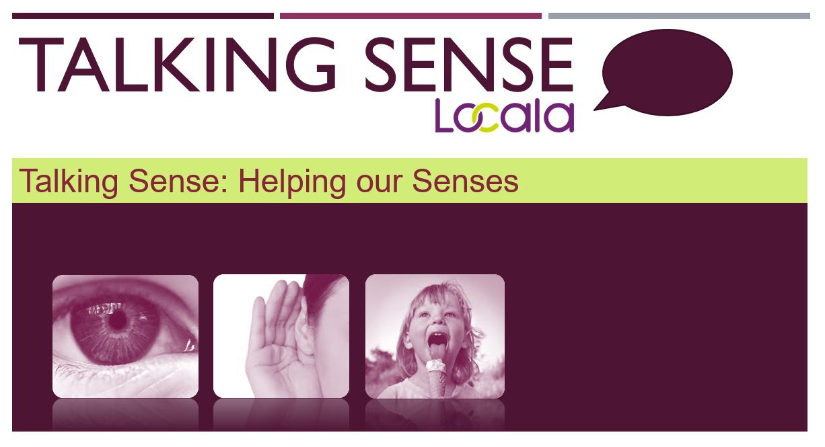
This resource contains templates for you to create your own resources, based on those suggested in the Talking Sense: Helping Our Senses presentations (part 4 and 5)

Contents:

- Sensory First Aid Kit (example)
- Sensory First Aid Kit Portable resource template
- Desk-a-cise printable resource
- How to create a laminated keyring using resource templates
- Sensory Ladder or Zones of Regulation resource
- Sensory Stress Bucket (example)
- Sensory Stress Bucket resource template

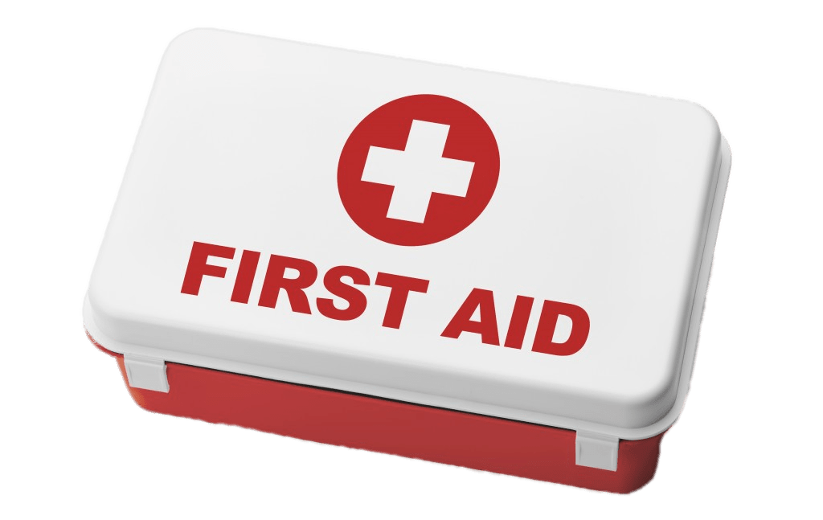
Sensory First Aid Kit
 | Examples: | My Kit:
Sensory Blockers | - Extra dark sunglasses / eye mask  - Ear plugs  - Headphones  - Scented items (e.g. essential oil diffuser bracelet) | 1)  2)  3)  4)
Sensory Fidgets | - Fidget jewellery  - Fidget pen  - Poppits keychain  - Flippable sequins item
Distraction Items | - Music  - Book / magazine  - Doodle pad  - Watch videos on phone | 1)  2)  3)  4)
System Organisers | - Hand therapy resource  - Desk-a-cise Flashcards  - Keychain Sensory Ladder


Sensory Blockers | Your text here
Sensory Fidgets | Your text here
Distraction Items | Your text here
System Organisers | Your text here

Desk-a-cise Flashcards:
Subtle move breaks for when you need to be more alert, but want to stay in the room or lesson
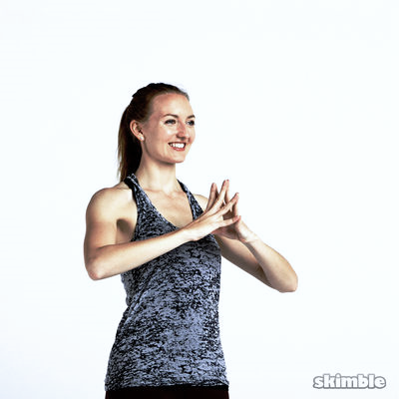  Fingertip Press | - Place fingertips together  - Push fingers firmly against each other  - You should feel some tension in the muscles in your forearms  - Hold for up to 5 seconds  - Repeat
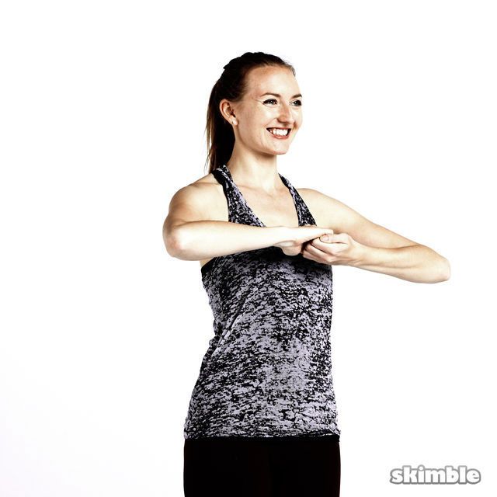  Finger Hook Pulls | - Make a ‘hook’ shape with the fingers of each hand  - Link hands together  - Pull outwards (keeping hands linked)  - You should feel some tension in the muscles in your shoulders  - Hold for up 5 seconds  - Repeat
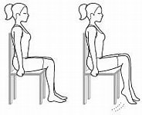  Heel Raises | - Sit with both feet flat on the floor  - Raise one (or both) heel(s)off the floor so on tiptoes  - Hold and lower  - Repeat
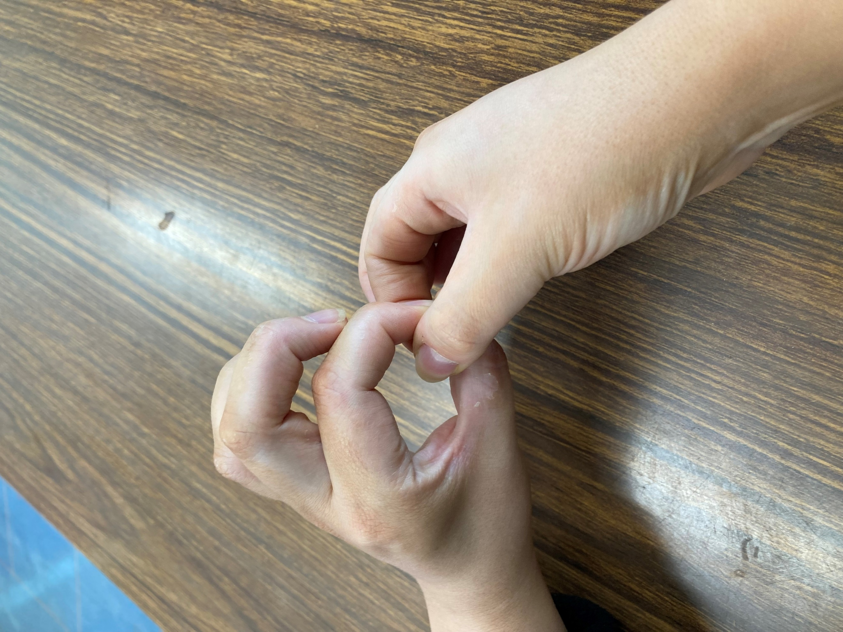  Link and Pull | - Touch index finger to thumb, forming a ‘circle’  - Touch thumb to index finger on other hand inside this ‘circle’ so hands are linked  - Pull outwards, keeping fingers linked  - Hold (5 seconds) and repeat

How to make a portable guide:
- Cut each resource table into ‘rows’
- Fold in half
- Laminate
- Hole punch
- Attach to a key chain
Your school or college may have a laminator. Ask support staff to help you make these resources!
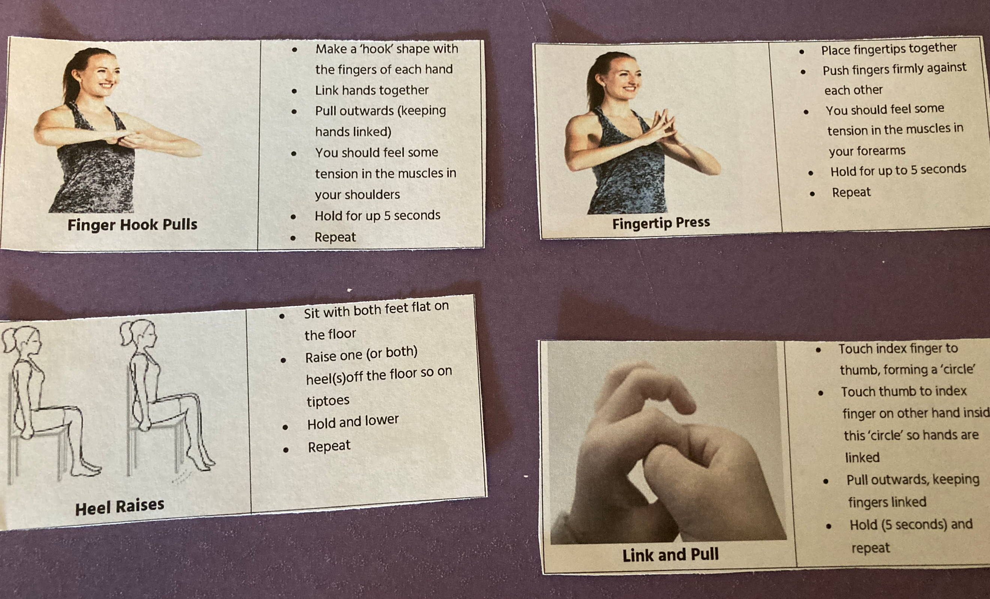

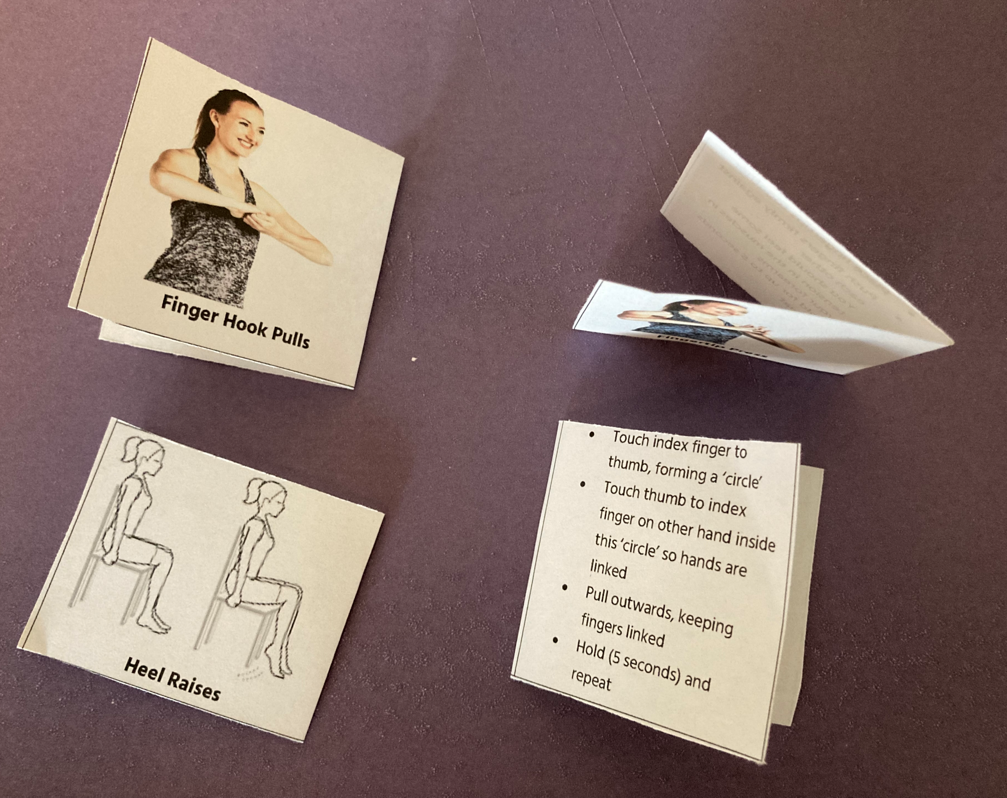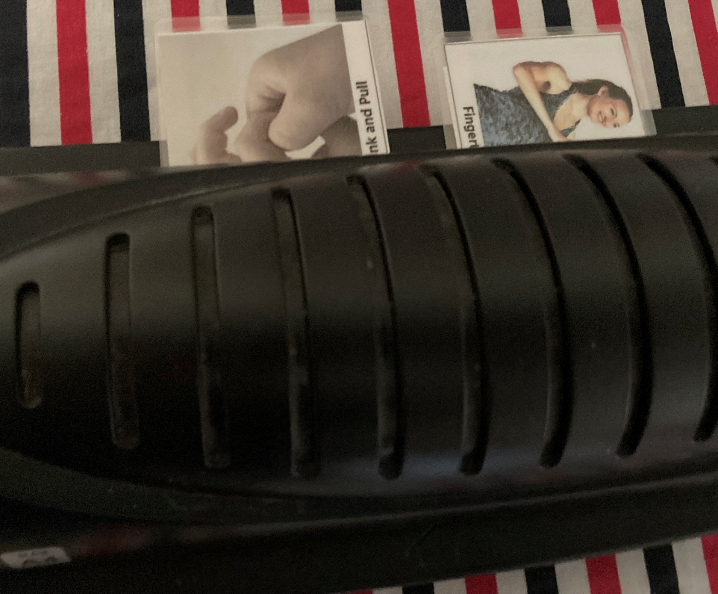
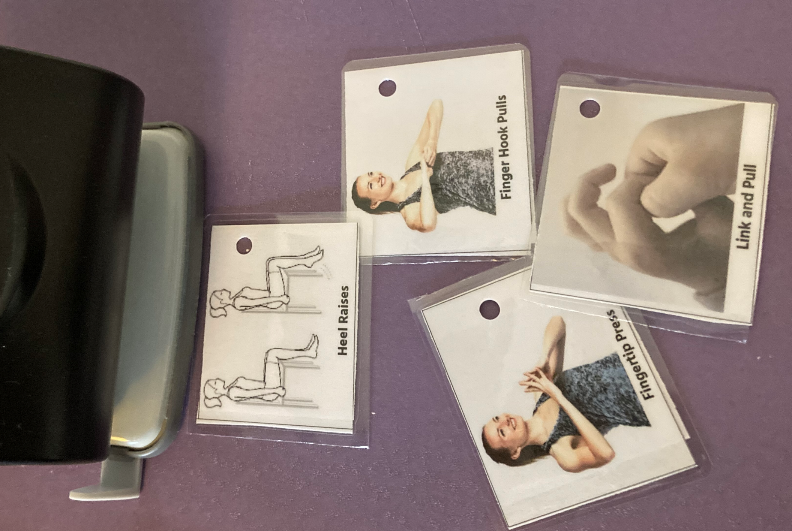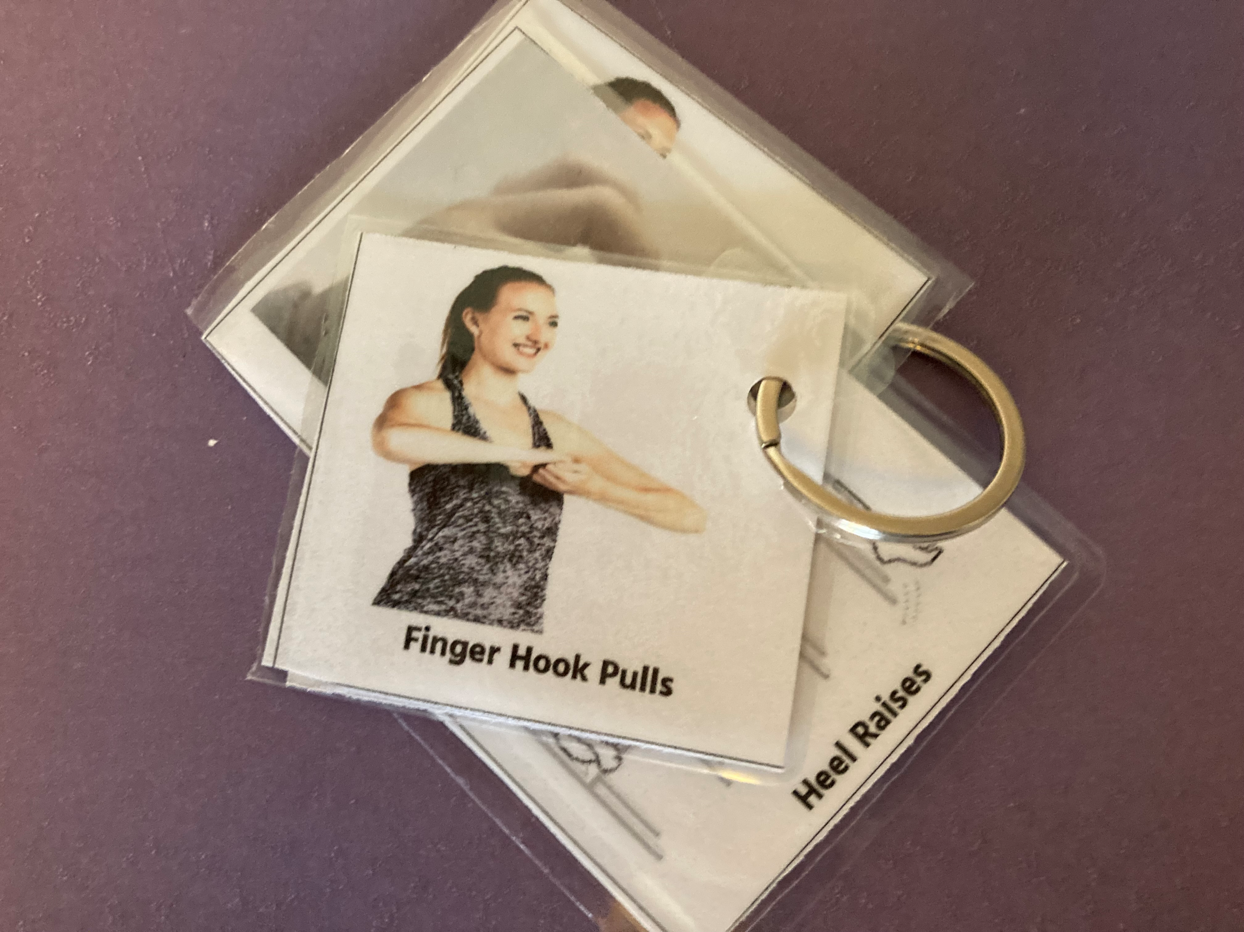

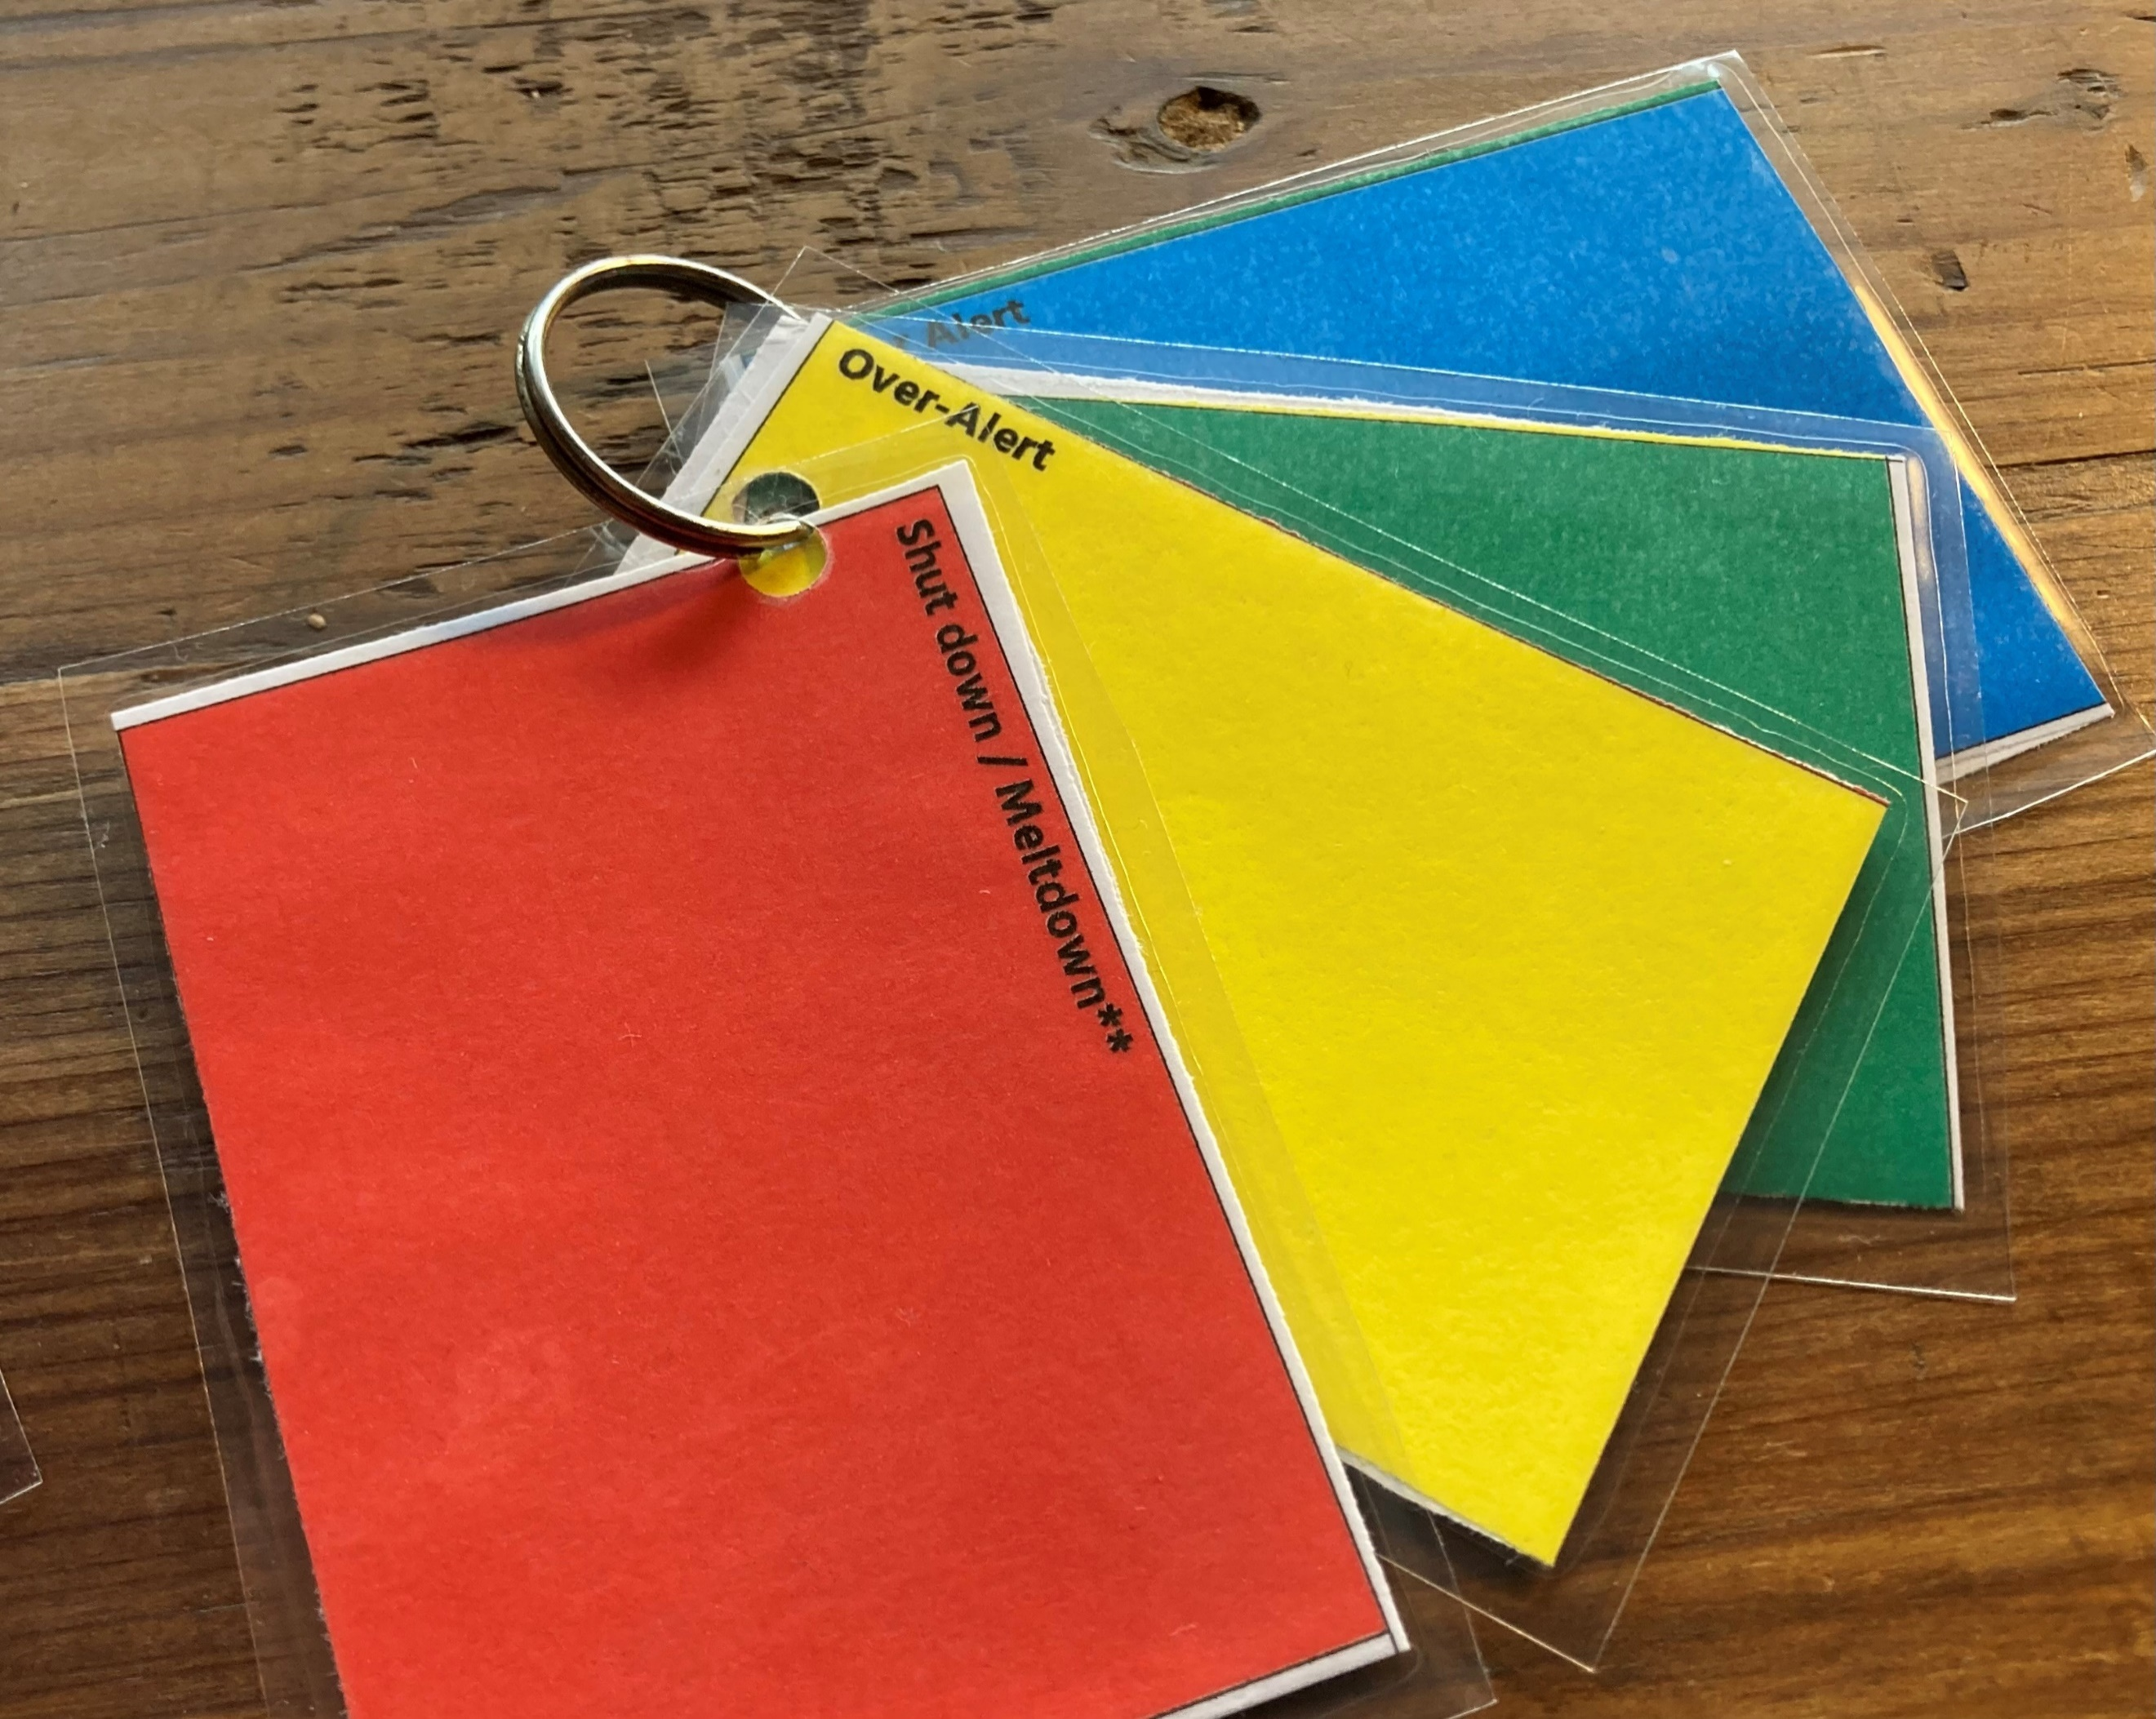
Shut down / Meltdown** | When we are in shut down, we cannot think, so make a plan beforehand with a trusted adult. It might be helpful if the person supporting you:  - Dims the lights  - Removes other people from the area  - Keeps you safe  - Stays nearby (but doesn’t interact until you are feeling calmer)  - Once you are calmer try yellow strategies
Over-Alert | - Quiet time in a calm, quiet space  - Calming music  - Deep pressure  - Yoga  - A breathing APP  - Distraction with a hobby / interest  - A repetitive activity (e.g. mindfulness colouring book, construction, crafting)  - Use Sensory First Aid-blockers
Just Right | - Yoga  - Sports session  - Brisk walk outside  - Use equipment in the school fitness suite  - Resistance bands  - Desk-a-cise (e.g. finger pulls)  - Resistance ‘hand therapy’ equipment  - Chew products / gum, crunchy food  - Use Sensory First Aid organisers and fidgets
Under Alert | - Movement break (which you can tolerate)  - Changing sensation (e.g. rhythmic tapping or squeezing on your arms)  - An iced / cold drink  - Music with a faster tempo  - Heavy muscle work can be used both to calm and to alert.  - Start off with gentle resistance exercises such as finger pulls
** Change the wording or add pictures if this helps you

Sensory Stress Bucket

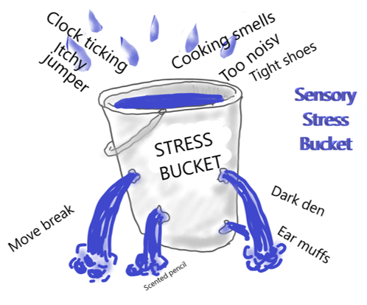

Examples:
Stressful Sensory Situations (‘drips’) | Possible Strategies (‘holes’)
Pens clicking, other people chatting | Ear plugs or headphones
Crowded Places | Sensory blockers (from Sensory First Aid Kit)  Ask for pass to leave lessons early
Tight clothing or uniform | Move break (heavy muscle work)
Having to sit still | Desk-a-cise
Smell of school toilets | Wear a mask  Essential oil diffuser

Activity: Think about sensory situations which are difficult or stressful for you. Write these down in the table below. What strategies do you use already? Write these down in the table and add any new ideas you may have after listening to the Talking Sense presentations
Stressful Sensory Situations (‘drips’) | Possible Strategies (‘holes’)

